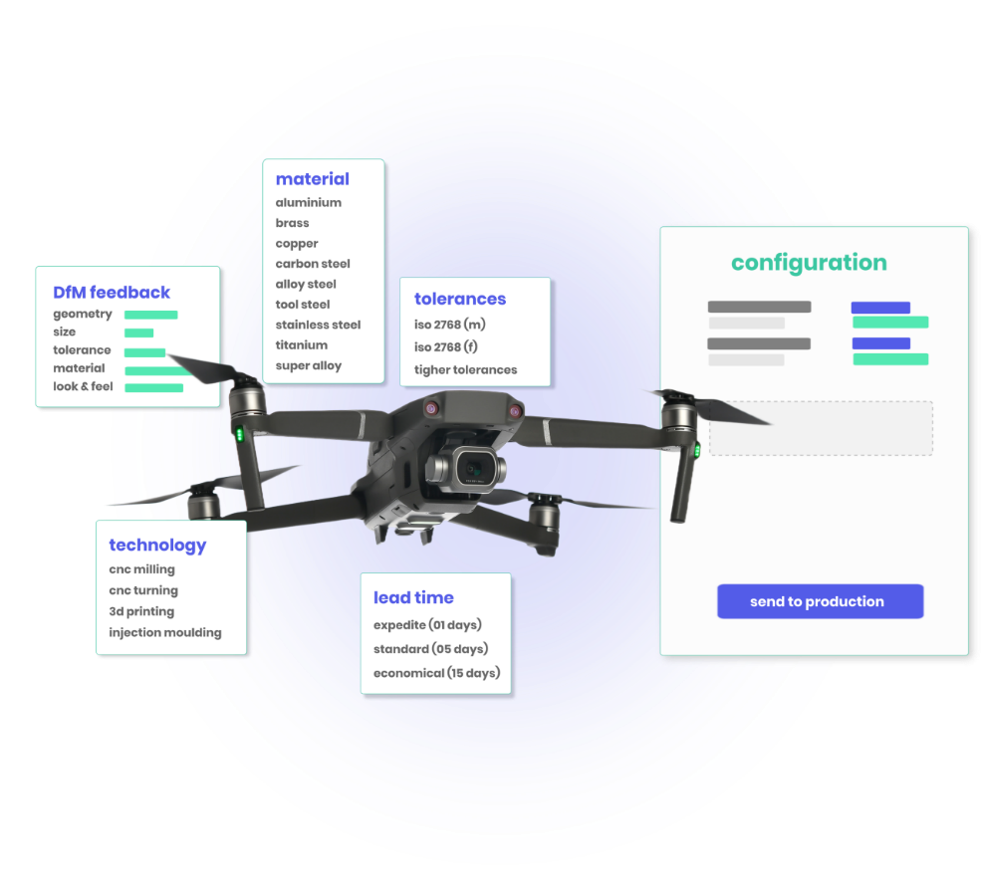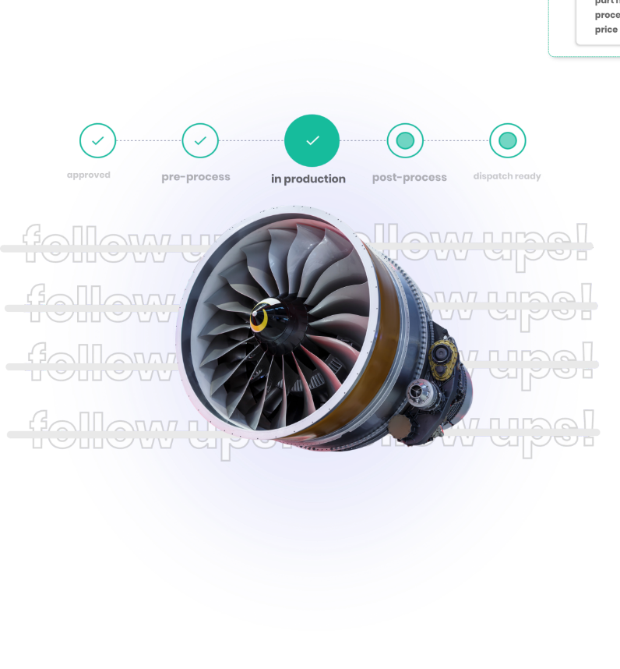

**unified manufacturing interface**

**Tired of finding multiple suppliers for your manufacturing requirements? Now, manage them all from a single window.**

**no more follow ups!**

**Stop taking frequent follow-ups. track your parts on your own and ensure end to end transparency!**

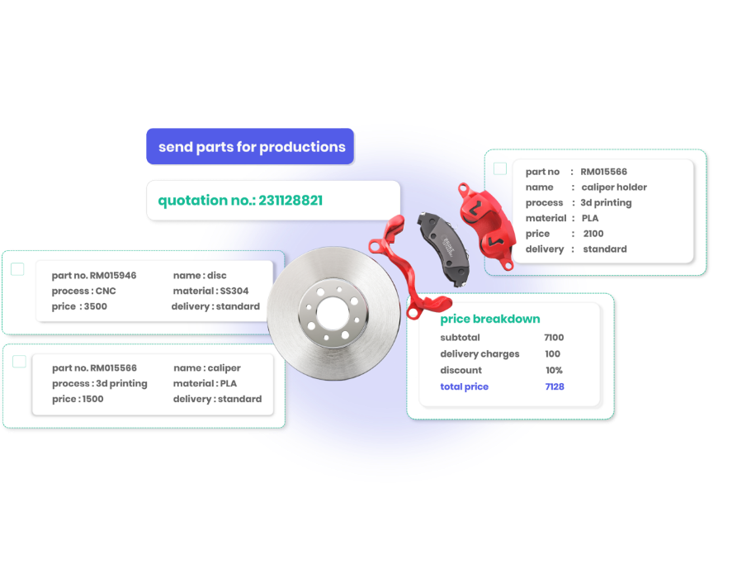

**complete BoM, in single purchase order**

**Why create different purchase orders for a single product? Include every child part in a single order regardless of the processes.**

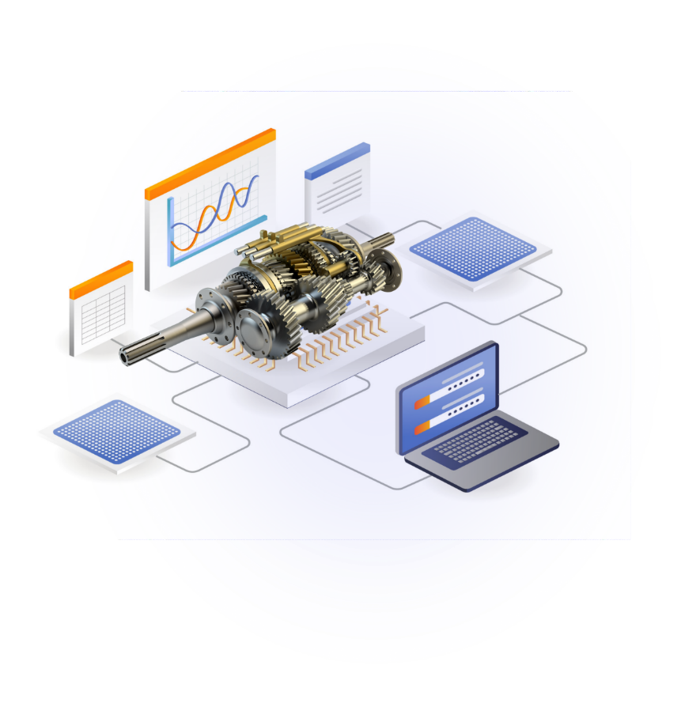

**rapid, in a true manner**

**rapid manufacturing today is hardly rapid enough. Experience rapid in a true manner with metlle.com.**

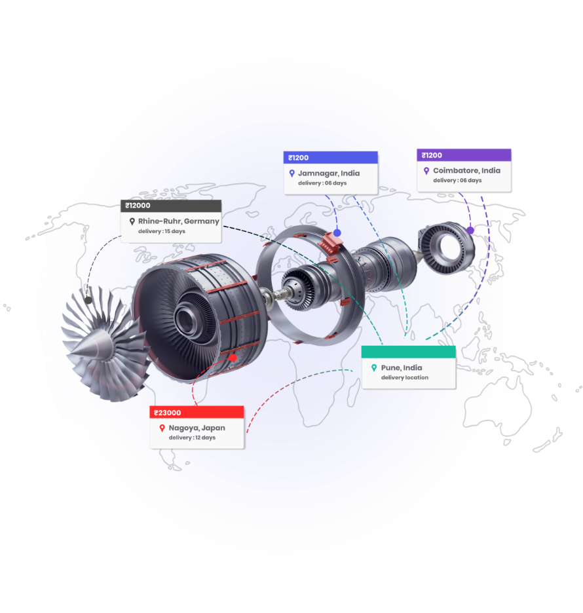

**distributed manufacturing,**

**a new normal**

**reduce dependency on nearby suppliers, get your part manufactured from the best. Distribute manufacturing to achieve quality your design deserves.**